Documentation for iDempier Ubuntu

**Step 1: Download Virtual Machine.**

Use this link <https://www.virtualbox.org/wiki/Downloads> to download and install the VM (Virtual Machine).

You see the **VirtualBox 6.1.30 platform packages** there is **Windows hosts** click this if you are using windows, you can also use the other option if you want.

Click **Windows hosts** to download. VirtualBox-6.1.30-148432-Win.exe

**Step 2: Download Ubuntu Server 20.04 LTS**

Use this link <https://wiki.idempiere.org/en/Install_Prerequisites> to more information. Scroll down if you find the **Install Ubuntu**

Click the refer to [www.ubuntu.com/download](http://www.ubuntu.com/download) link.

Inside the Ubuntu website look you for the **Ubuntu Server** click it and it will take you to the Ubuntu server download page.

Click **Options 2 – Manual server installation**.

Click the **Download Ubuntu Server 20.04 LTS.**

After you click Download Ubuntu Server 20.04 LTS. It will automatically download and wait for it to finish.

**Step 3: Installation and setup.**

Open **File Explorer** and go to **Downloads**.

Open your **VirtualBox-6.1.30-148432-Win.**

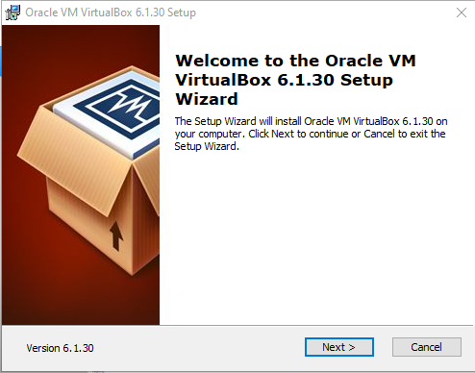

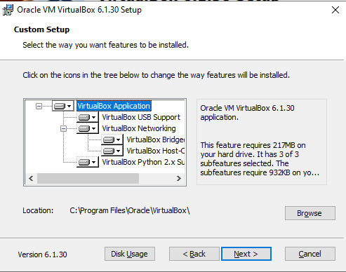

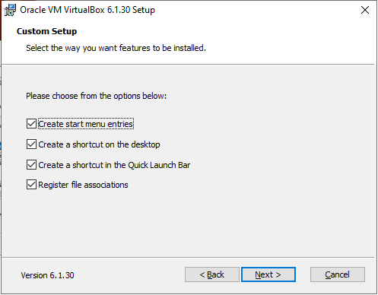

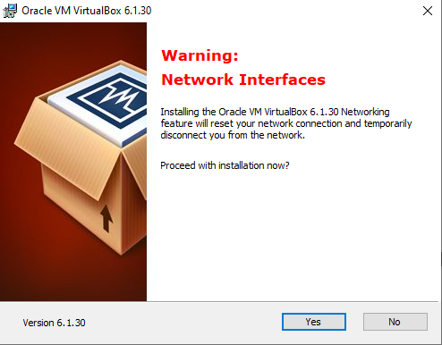

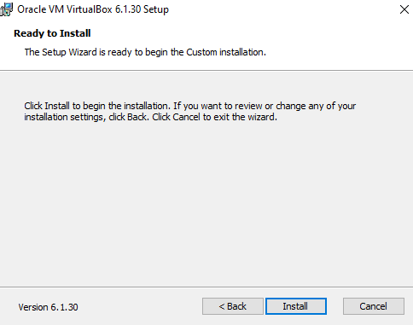

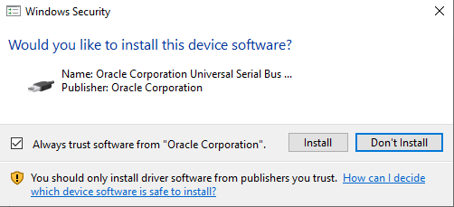

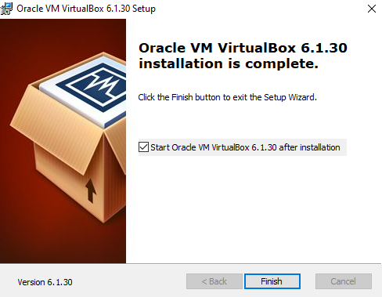

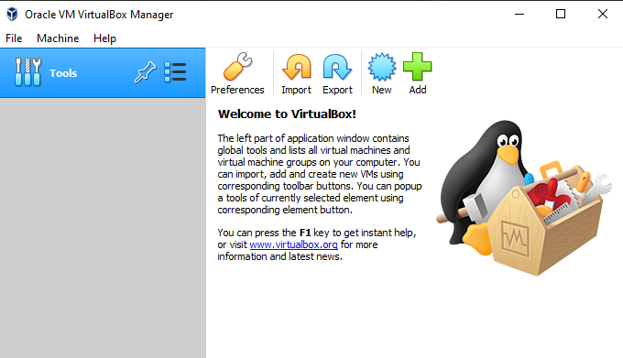

**Step 4: Create VM Server and set up.**

To create click this icon  there is a pop-up window appear. 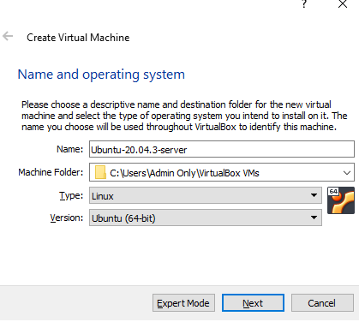

You can name what you want. For this let’s use the information below.

Name: **Ubuntu-20.04.3-Server**,

Type: **Linux**

Version: **Ubuntu (64bit)**

For the memory size, the recommended is **2MB to 4MB** for a stable system. For me I set it to **3MB.**

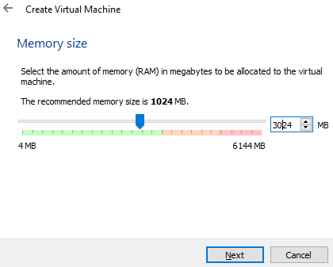

**Hard Disk** set it to **Create a virtual hard disk now.** and click next.

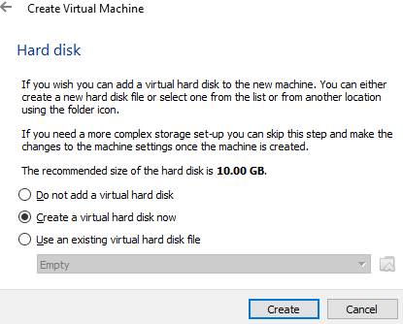

**Hard Disk Type** set it **VDI (VirtualBox Disk Image)** and click next.

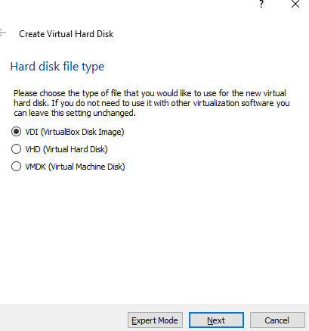

**Storage on physical hard disk** set it to **Dynamically allocated** and click next.

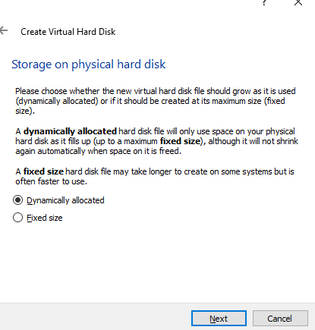

**File location and size** recommended is **50GB** minimum. And click create.

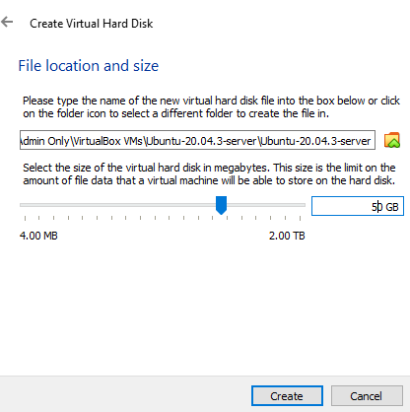

We created the server.

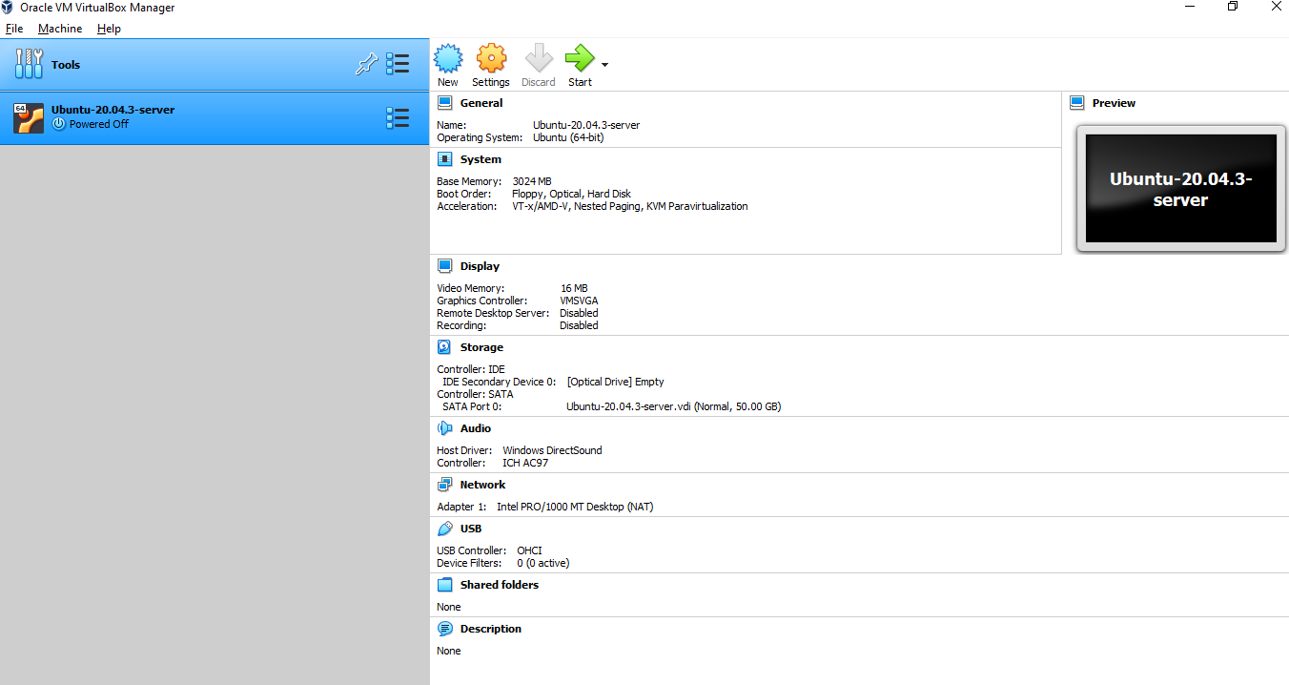

Next, lets add some additional setting by clicking the Settings  , and click the **General Advance** tab. Set you’re.

Shared Clipboard: **Bidirectional**

Dran’n’Drop: **Bidirectional**

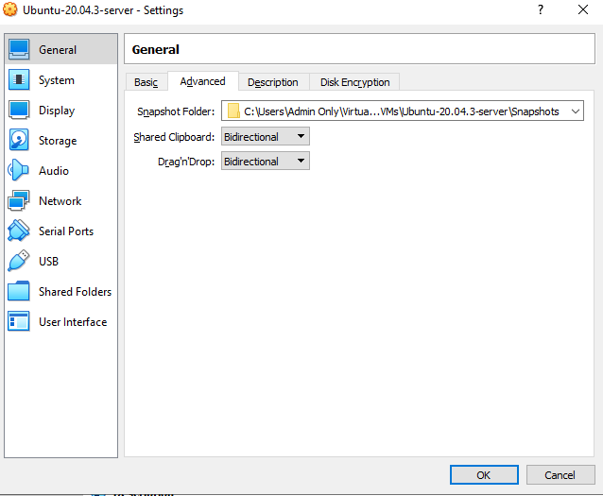

Click the System check the **Network**. And,

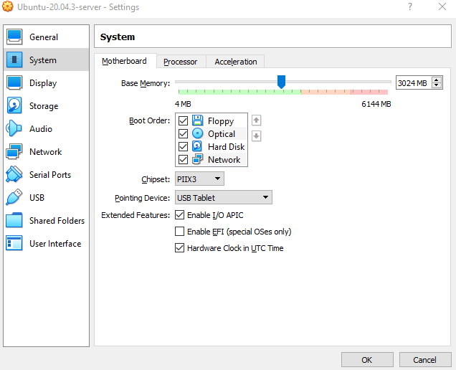

Click **Processor** and set you CPUs. You can set want it whatever you want. In my case I got a slow pc I set it to **2 CPU.** And you can also check the to extended**.**

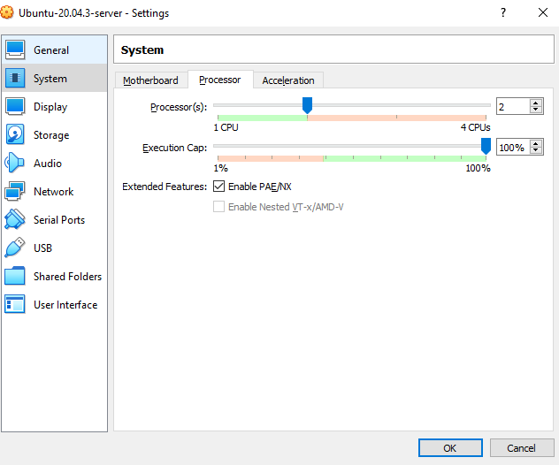

Next, Go to the **Display** tab.

Set your **Video Memory:** to max 128MB

You can also Check the 3D Acceleration, its optional

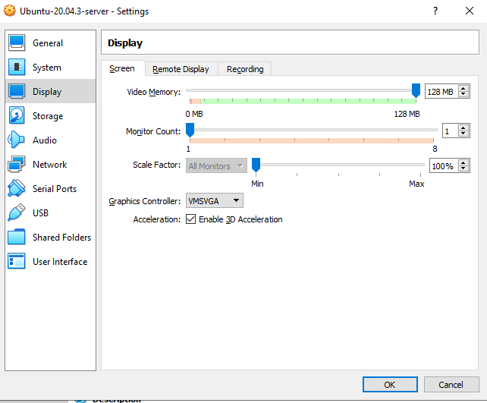

Next, Go to **Storage** tab. In storage devices click the **Empty,** the attributes will show up and click the blue disk  and **Choose Files**.

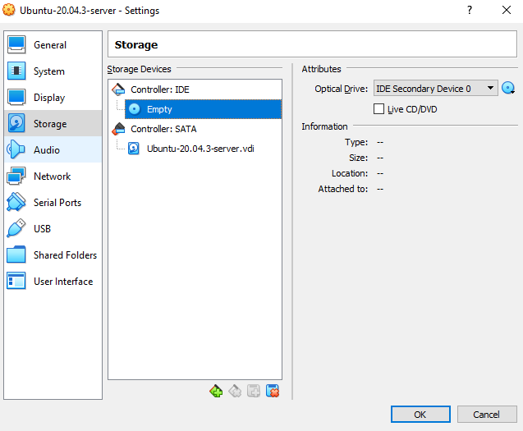

The file explorer will pop up. Go to download and select the Ubuntu server that you downloaded. And click open.

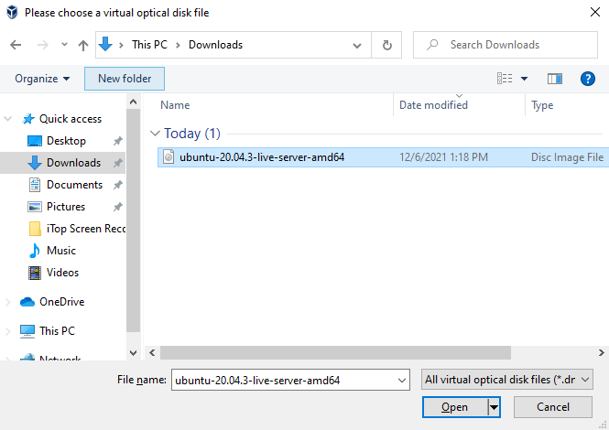

Click **ok** and we are good to go.

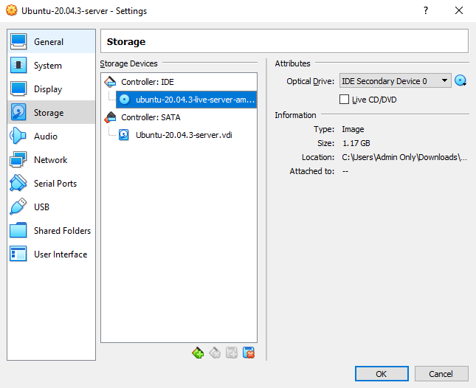

**Step 5: Installing Ubuntu server**

We are ready to install are Ubuntu, to start installing just simply click the **start** botton. 

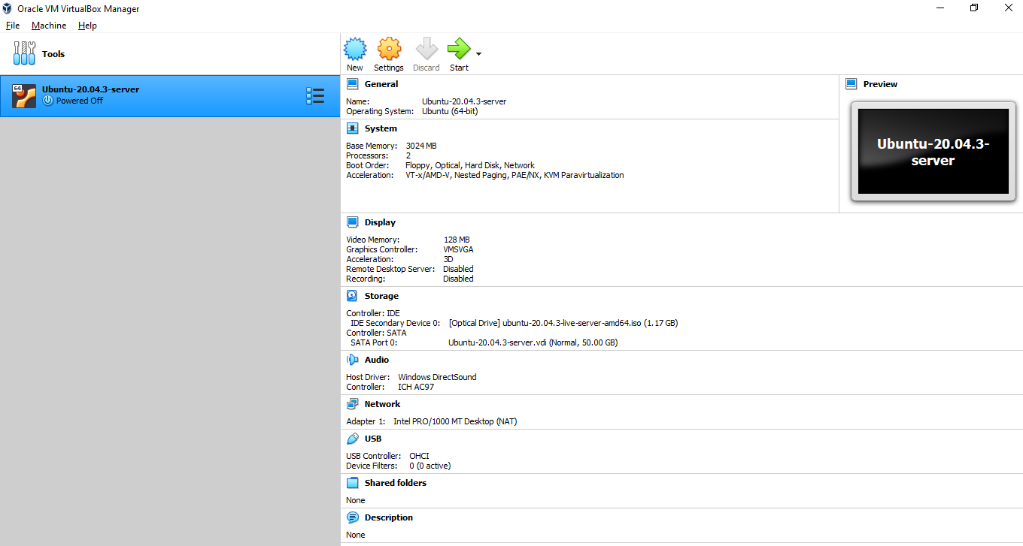

This windows pop up, Select **English** and press **Enter** on your keyboard because we can’t you mouse in this interface.

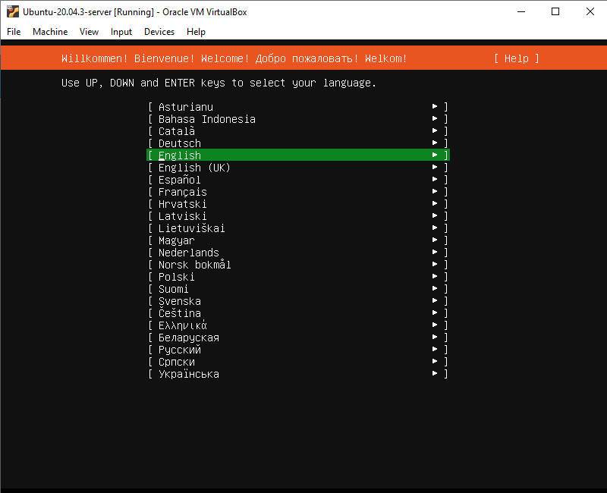

Next, Just select **Continue without updating** because we are using the Ubuntu 20.04.3**.**

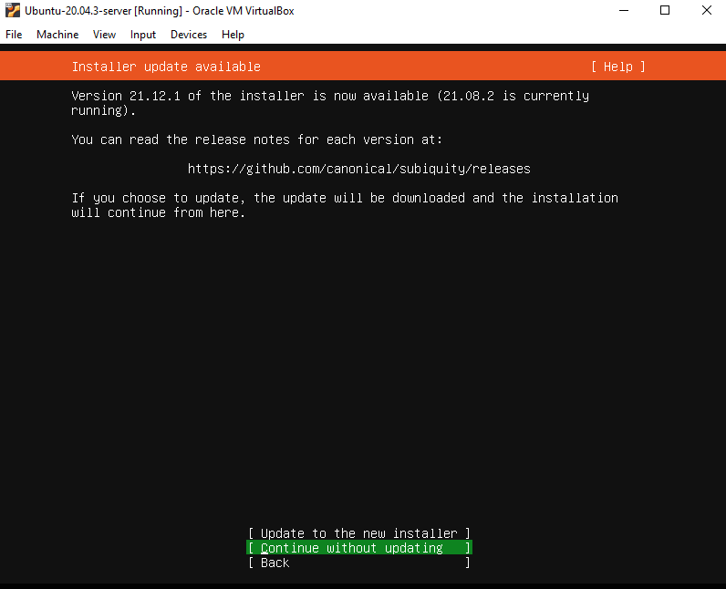

Select **Done** and press Enter until this part will show up.

you must make sure to remove the **ph**. that in the website address as it will cause a lot of errors during the installation.

Select **Done** and press Enter.

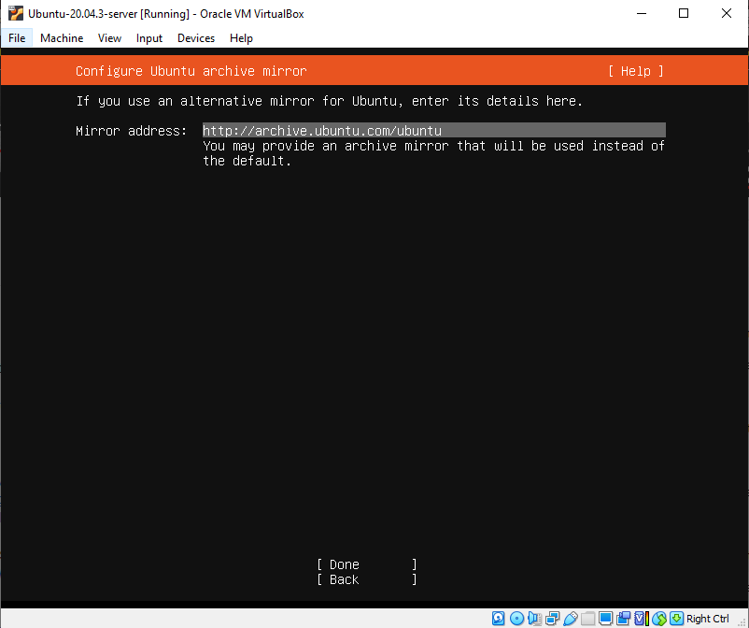

Next, Select **Done** and press Enter. Until this will show up, just select continue and press enter.

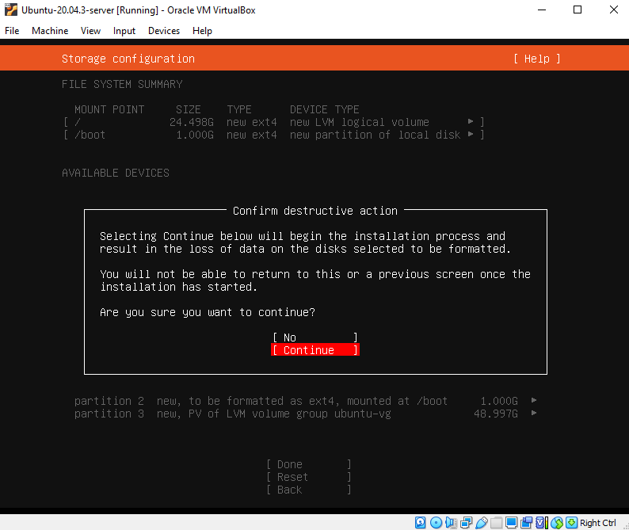

We are now creating our system profile. Fill it up and if you done just select done and press enter.

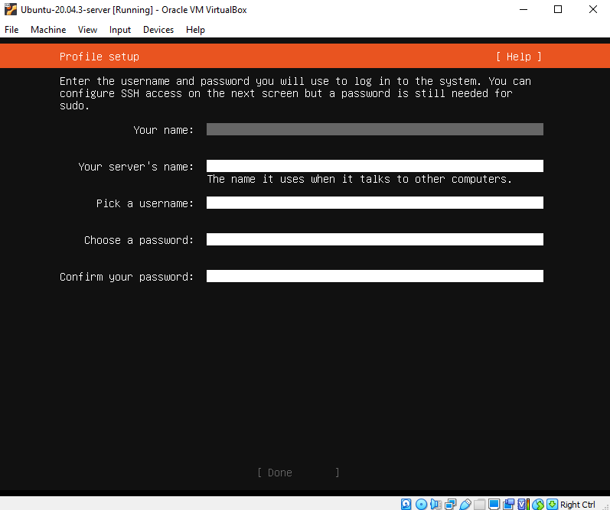

Next, on **Install OpenSSH server** just press enter to select, it will mark an [X] and you can now select done and press enter.

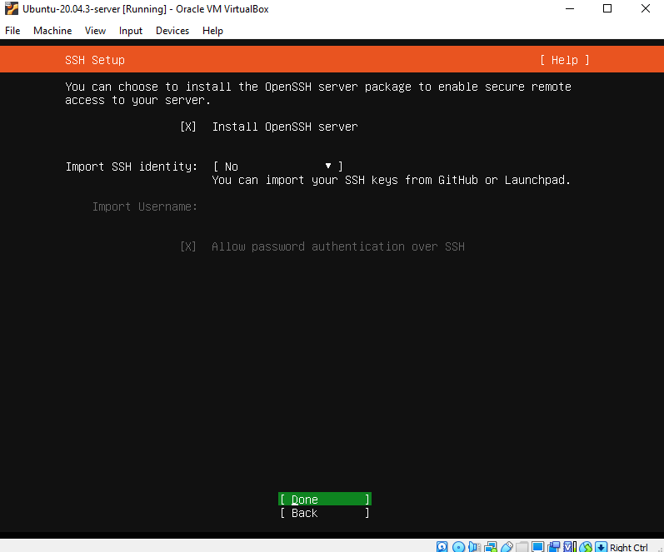

Select **Done** and press **Enter,**

Until this show up, just wait until the installation is done.

(noted: Installation need some time… )

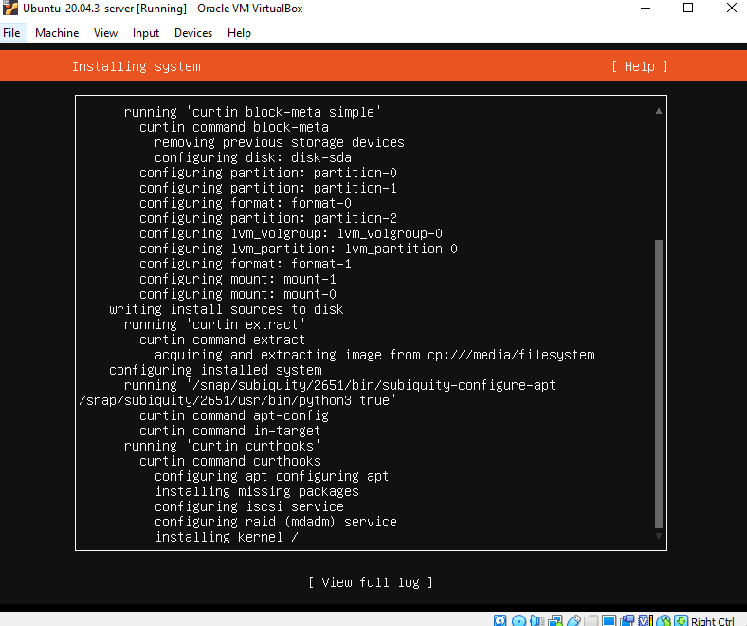

Done! You can now select **Reboot Now** and press enter.

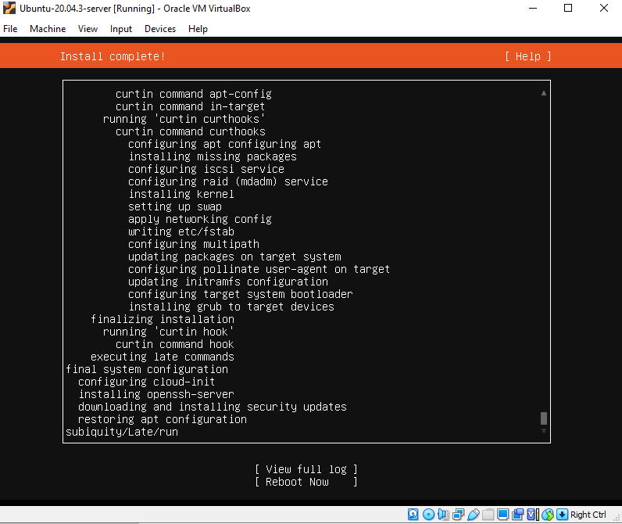

After you reboot the Ubuntu this show up, its ready to add some UI.

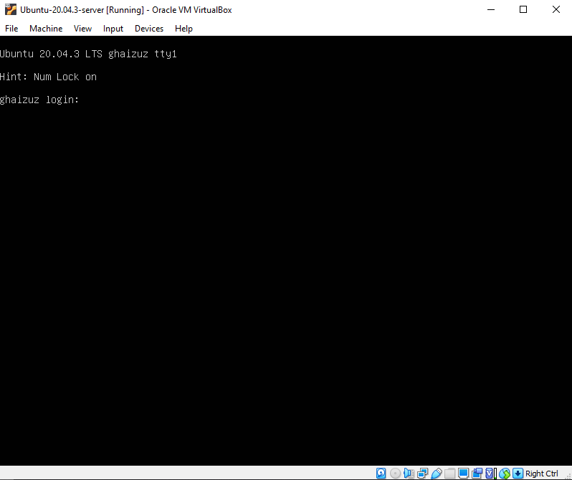

**Step 6: adding the Ubuntu UI**

Login your account that you set in profile set up.

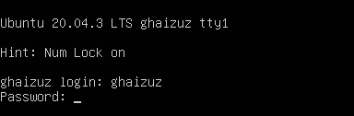

you can now proceed on adding command.



I recommended that we switch and use the root user to switch to the root.

By using this command **sudo -i**.

(Login as root)



We are now already logged in as root user.



**(Update Ubuntu)**

To update use the command below.



Press **Enter**. Wait until the update is finished.

Next, to update the package list use the command below.



Press **Enter**. Wait until the update is finished.



**(Install Tasksel)**

Tasksel is a debian and Ubuntu operating system tool this is going to be the tool that we

will use in selecting the type of Ubuntu user interface that we want to install

In order to install **tasksel** use the command below.



Press **Enter**. Wait until the update is finished. If it ask Y/N select Y for yes.

**(Run Tasksel)**

To run tasksel use the command below.



Then inside tasksel you can use arrow keys up and down to navigate and then spacebar to select.

Inside tasks look for **Ubuntu desktop** and press spacebar to select it once it's already selected.

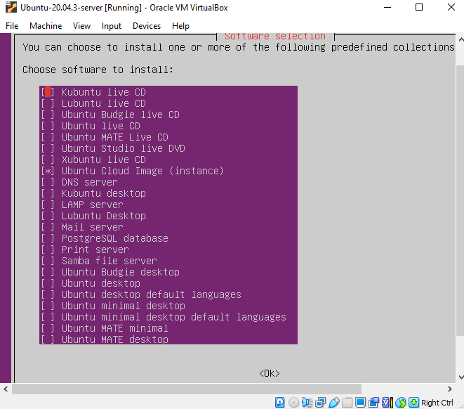

Once it's already selected move to the ok selection below by pressing tab then press enter.

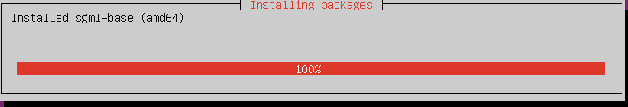

Wait until the update is finished. If the installation is complete you can reboot your machine.

Use this command below.





**Step 7: Installing PostgreSQL 13**

To install pSQL (PostgreSQL) we need you use the following commands.

To make sure that we encounter no issue or error during the installation i recommend that we login as the root user.

**sudo -i**



Put you password then Press ENTER.

Then to Create the file repository configuration:

**sudo sh -c 'echo "deb http://apt.postgresql.org/pub/repos/apt $(lsb_release -cs)-pgdg main" > /etc/apt/sources.list.d/pgdg.list'**



Next, is we are going to Import the repository signing key. By using the command below.

**wget --quiet -O - https://www.postgresql.org/media/keys/ACCC4CF8.asc | sudo apt-key add –**



Press ENTER.

Next, is to update the package lists. use the command below.

**sudo apt-get update**



Press ENTER and wait for it to finish.

When its done we are now going to install version 13 of PostgreSQL.

**sudo apt-get -y install postgresql-13**



Then press ENTER and wait for it to finish.

**STEP 8: Assign a password to user Postgres**

In order to create the database, the installer needs to know the password of user Postgres, by default this user doesn't have a password in ubuntu (windows installer asks for a password).

Please take note of the password you assign here as it will be required in the setup process:

Steps are (replace your_chosen_password by your preferred): Use the command below.

**echo "alter user postgres password 'your_chosen_password'" | sudo su postgres -c "psql -U postgres"**



Set your password then press ENTER

Just ignore this error.



When its done we are now going to check Configure pg_hba.conf.

To do that follow this command.

**sudo nano /etc/postgresql/13/main/pg_hba.conf**



Then press ENTER

This will show up use your arrow key to navigate and find “local” is for Unix domain socket connections only and change the **peer** to **md5.**

After you change it press **CTRL + X** after that press **Y** Then ENTER.

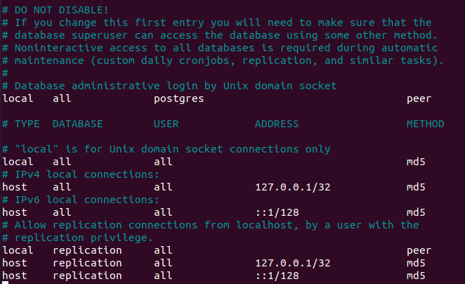

After that let’s reload the configuration. By using this command.

**sudo service postgresql reload**



Press ENTER. And we are done with pSQL installation.

**STEP 9: To Install OpenJDK 11**

To install the openjdk 11 first we going to update a Ubuntu package by using this command.

**sudo apt-get update**



Press ENTER and wait until it’s done.

Next, is use this command to install openJDK

**sudo apt-get install openjdk-11-jdk**



Press ENTER

When this will show up just simply press **Y** and press ENTER



wait until it’s done. And we are done on installing OpenJDK 11.

**STEP 10: Download iDempiere installer**

To download the iDempiere installer simply use this command below.

**wget** [**https://sourceforge.net/projects/idempiere/files/v8.2/daily-server/idempiereServer8.2Daily.gtk.linux.x86_64.zip**](https://sourceforge.net/projects/idempiere/files/v8.2/daily-server/idempiereServer8.2Daily.gtk.linux.x86_64.zip)

press ENTER, and wait the download is done.

After we download that we need to add users It is recommended to run the iDempiere server as a user created for such purpose, usually idempiere, instead of running as root.

So, let's create first a user: by using this command.

**adduser idempiere** and press ENTER.



You can set a password for your user.



And the rest set it to default by not filling it up.

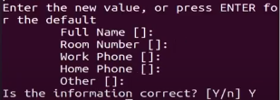

Then press **Y** and press ENTER.

Next, Unzip the server installer you downloaded or created. by using the command below.

**jar xvf idempiereServer8.2Daily.gtk.linux.x86_64.zip**



After that, we need to move it OPT.

Use this command and execute it 1 by 1.

**mv idempiere.gtk.linux.x86_64/idempiere-server /opt**



**rmdir idempiere.gtk.linux.x86_64**



**chown -R idempiere:idempiere /opt/idempiere-server**



After that, we are now ready to set up the iDempiere server.

**STEP 11: Setup iDempiere Server**

Reboot your Ubuntu server and log in to iDempiere user.

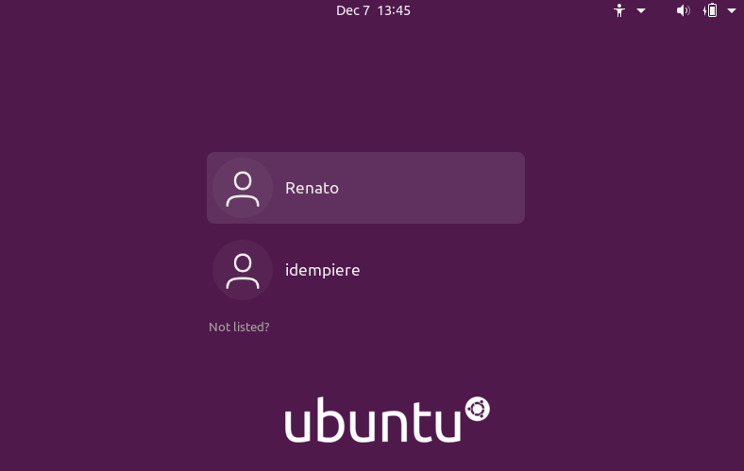 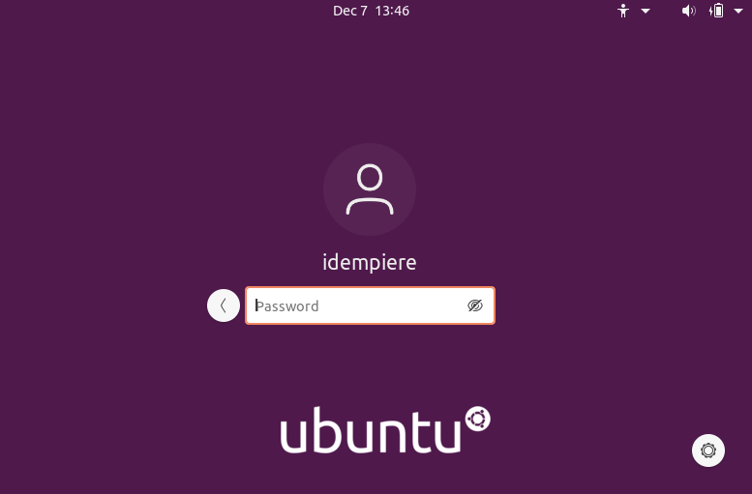

Enter the password that you set in add user.

After that now we need to log in using user iDempiere to set up idea server in the command line navigate to where the item peer setup that is his located. By using this command.

**cd /opt/idempiere-server** And press ENTER.



Also in this phase, we no longer need to be in the root user when using the command line as it is recommended to run and set up iDempiere server using the user.

To Run iDempiere set up just simply use this command.

**sh setup-alt.sh** and press ENTER.



iDempiere server setup will show up just leave everything by default.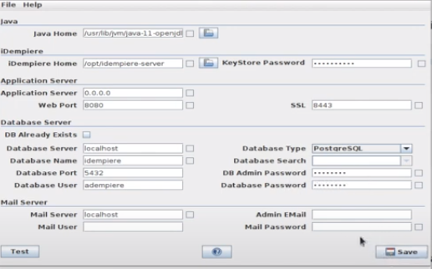

and then in the db admin password and database password just type the postgres password you created during the installation and setup of postgresql 13. once done try pressing test button below to test if all is working fine

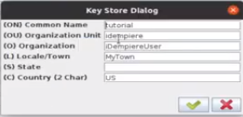 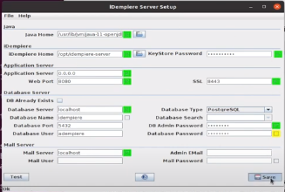

After that just click save.

**STEP 11:** **Import the Database.**

We are now importing the database, just use the command below.

**cd /opt/idempiere-server/utils** and press ENTER



And then use this command. **sh RUN_ImportIdempiere.sh** and press ENTER and wait until its done.



**STEP 12: Update the Database**

To update the database you this command below.

**cd /opt/idempiere-server/utils** and press ENTER



And then use this command**. sh RUN_SyncDB.sh** and press ENTER and wait until its done.



**STEP 13: Register version code in database**

To do that just use the command below.

**cd /opt/idempiere-server** and press ENTER



And then use this command **sh sign-database-build-alt.sh** and press ENTER and wait until its done.



Once it’s done our iDempiere is ready to be used.

**STEP 14: Manual running**

To run your iDempiere just follow the command below.

**cd /opt/idempiere-server** and press ENTER.



And then use this command **sh idempiere-server.sh** and press ENTER



wait a couple of mins and open a browser inside you Ubuntu and search localhost:8080

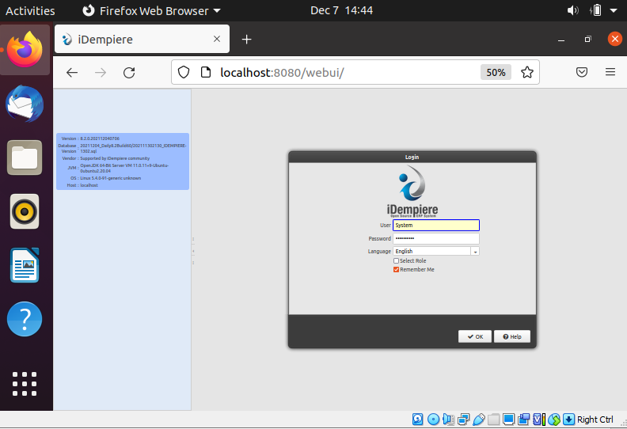

NOW WE ARE READY TO GO